Assembly 1

Computer Components
Components of a computer important to its operation:
- CPU – the “brain”
- Memory – where data and instructions are stored
- Bus (datapath) – how data is transferred
- Clock/Interrupts – how routines are scheduled
- Inputs/Outputs (I/O) – how the computer communicates with the users

The CPU
The computer’s CPU fetches, decodes and executes program instructions. Its two principal parts are the datapath and the control unit.
- The datapath consists of an arithmetic-logic unit (ALU) and storage units (registers) that are connected to each other, and to main memory, by a data bus.
- The control unit sends signals to tell the various components within the CPU to perform sequenced operations.
Registers hold data that can be readily accessed by the CPU.
- They can be implemented using D flip-flops (a type of digital circuit)
  - e.g.: a 32-bit register requires 32 D flip-flops.
The arithmetic-logic unit carries out logical and arithmetic operations as directed by the control unit.
The control unit determines which actions to carry out according to the values in the program counter register and a status register.

Memory
Computer memory consiuts of a linear array of addressable storage cells similar to that of registers.
- It can be byte-addressable or word-addressable, where a word typically consists of two or more bytes.
- It is constructed of Random Access Memory (RAM) chips, often reffered to in terms of their length (number of locations in memory) and width (word size).
- If the memory word size of the machine is 16 bits, then a 4M x 16 RAM chip gives 4 megabytes of 16 bit memory locations.
How does a computer access a memory location corresponding to a particular address?
- We observe that 4M can be expresseds as 2² x 2²⁰ = 2²² words.
- The memory locaations or this memory are numbered: 0 –> 2²² - 1
- Thus, the memory bus of this system requires at least 22 address lines.

Input/Output subsystem
A computer communicates with the outside world through its input/output subsystem.
I/O devices connect to the CPU through various interfaces, like:
- Memory-mapped where the I/O device behaves like main memory from the CPU’s point of view
- Instruction based where the CPU has a specialised I/O instruction set.

The Bus
The CPU shares data with other system components through the data bus.
- A bus is a set of wires that simultaneously convey a single bit along each line.
The two types of bus are commonly found in computer systems:
- point to point (two components linked together)
- Multipoint buses (several components all connected together along one common bus, accessed via different protocols)
Buses consist of data lines, control lines, and address lines.
- Data lines convey bits from one device to another
- Control lines determine the direction of data flow, and when each device can access the bus
- Address lines determine the data source or destination location.
In a master-slave configuration, where more than one device can be the bus master, concurrent bus master requests must be arbitrated.
Four categories of bus arbitration are:
- Daisy chain where permissions are passed from the highest priority to the lowest.
- Centralised parallel where each device is directly connected to an arbitration circuit.
- Distributed using self-detection where devices decide which gets the bus among themselves
- Distributed using collision detection where any device can try to use the bus, but if its data collides with the data of another device, it tries again.

Clocks and Interrupts
Every computer contains at least one clock that synchronises the activities of its component.
- A fixed number of clock cycles are required to carry out each data movement or computational operation.
- The clock frequency, measured in megahertz or gigahertz, determines the speed with which all operations are carried out.
- Clock cycle time is the reciprocal of clock frequency.
  - An f_{c} = 800MHz clock has a cycle time of T_{c} = 1.25 ns
Clock speed should not be confused with CPU performance.
The CPU time required to run a program is given by the general performance equation:
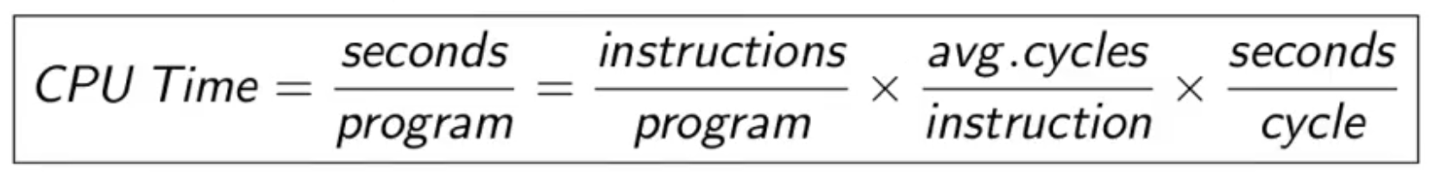
So we can improve CPU throughput if we:
- Reduce the number of instructions in a program (embedded systems)
- Reduce the number of cycles per instruction
- Reduce the number of seconds per clock cycle.
Interrupts allow normal execution of a program to be altered when an event of higher-priority occurs. They alert the CPU to such events. They can be triggered by e.g.:
- I/O requests
- Arithmetic errors (e.g. division by zero)
- Encountering invalid instructions
Each interrupt is associated with a procedure that directs the actions of the CPU to handle the evnet.

MARIE
MARIE stands for Machine Architecture that is Really Intuitive and Easy.
MARIE has the following characteristics:
- Binary, two’s complement data representation
- Stored program, fixed word length data and instructions
- 4K words of word-addressable main memory
- 16-bit data words
- 16-bit instructions, 4 for op code and 12 for the address
- A 16-bit ALU
- Seven registers for control and data movement
MARIE’s seven registers are:
- Accumulator, ACSimilarly, the RTL for the ADD instruction is:
  - A 16-bit register that holds conditional operator (e.g., “less than”) or one operand of a two-operand instruction.
- Memory Address Register, MAR
  - a 12-bit register that holds the memory address or the operand of an instruction
- Memory buffer register, MBR
  - a 16-bit register that holds data after retrieval from, or before placement in emmory
- Program counter, PC
  - a 12-bit register that holds the address of the next program instruction to be executed.
- Instruction register, IR
  - a 16-bit register which holds an instruction immediately preceding its execution
- Input register, IN
  - an 8-bit register that holds data read from an input device.
- Output register, OUT
  - an 8-bit register that holds data that is ready for the output device.
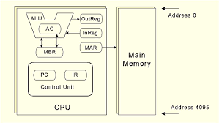

The registers are interconnected, and connected with main memory through a common data bus.
- Each device on the bus is identified by a unique number. This number is set on the control lines whenever the corresponding device is required to carry out an operation.
Separate connections are also provided between:
- The AC and the MBR
- The ALU, AC and MBR
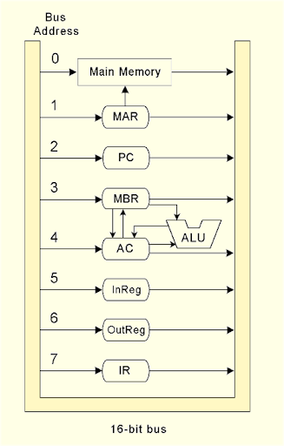
This permits data transfer between these devices withou the use of the main data bus.

MARIE’s Instruction Set Architecture
A computer’s instruction set architecture (ISA) specifies the format of its instructions and the primitive operations that the machine can perform.
- The ISA is an interface between a computer’s hardware and its software.
- Some ISAs include hundreds of different instructions for processing data and controlling program execution.
The MARIE ISA consists of 13 instructions.
This is the format of a MARIE instruction
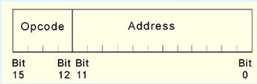

and the fundamental MARIE instructions are:
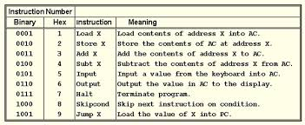

The bit pattern for a load instruction as it would appear in the IR:
Opcode | Operand
0001 | 1000000000011

Altogther, looking like 00011000000000011

For Skipcond

Opcode | Operand
1000 | 1000000000000

We see that the opcode is 8 and bits 11 and 10 are 10, meaning that the next instruction will be skipped if the value in the AC is greater than zero.

Note that, Skipcond uses the following codes:
- 00 – skip if AC < 0
- 01 – skip if AC = 0
- 10 – skip if AC > 0

Register Transfer Language
Each of our instructions actually consists of a sequence of smaller instructions called micro-operations.
The exact sequence of micro-operations that are carried out by an instruction can be specified using register transfer language.
- In the MARIE RTL, we use the notation M[X] to indicate the actual data value stored in memory location X, and ← to indicate the transfer of bytes to a register or memory location.
The RTL for the LOAD instruction is:
MAR ← X
MBR ← M[MAR]
AC ← MBR
Similarly, the RTL for the ADD instruction is:
MAR ← X
MBR ← M[MAR]
AC ← AC + MBR

